**Phase Transformations and Hardenability of Steel**

Ian Wise, EMSE 330

**Abstract**

Steel is a universally-recognized structural material made via adding small concentrations of carbon to iron. Carbon interstitially combines with the iron to form a strong solid solution that exhibits good mechanical properties, including hardness, for many engineering applications. Additional transition elements can be added to the iron as well to produce stronger steels with good hardenability, or the ability to form strong Fe-C phases upon quenching. This experiment observes the differences in microstructure and hardness among two plain-carbon and two alloy steels with different heat treatment methods. Optical microscopy was used to examine the microstructure, and hardness test were conducted. Larger bars of each steel were subjected to a Jominy test followed by hardness testing to compare the hardenability of the steels.

**Introduction**

 As one of the most commonplace structural materials, steel and steel alloys remain integral to a significant majority of modern societies. Therefore, it is necessary to understand the properties of steel and the effects of heat and alloying elements on those properties in order to efficiently utilize steel in modern applications. Many mechanical properties of steel are directly connected to the microstructure of the material, which can change as a function of heat treatment temperature and as new elements are added to the iron matrix. The most important of these elements, carbon, is widely understood in terms of its interactions with iron, as Figure 1 (the Fe-C phase diagram) displays.

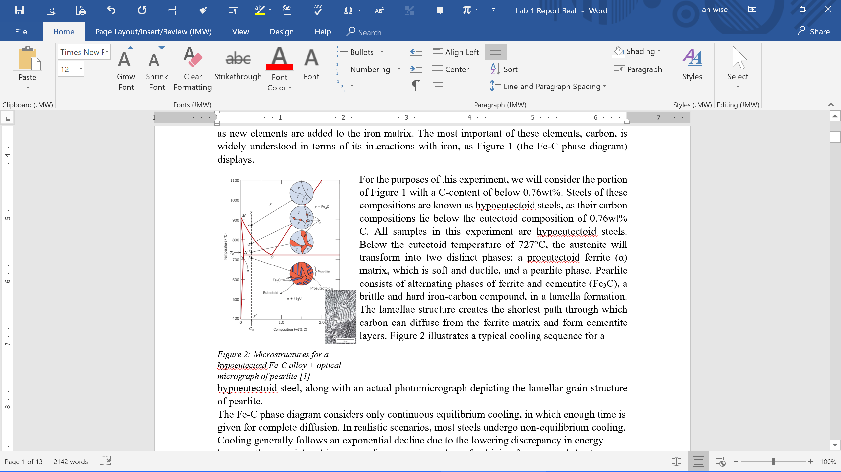For the purposes of this experiment, we will consider the portion of Figure 1 with a C-content of below 0.76wt%. Steels of these compositions are known as hypoeutectoid steels, as their carbon compositions lie below the eutectoid composition of 0.76wt% C. All samples in this experiment are hypoeutectoid steels. Below the eutectoid temperature of 727°C, the austenite will transform into two distinct phases: a proeutectoid ferrite (α) matrix, which is soft and ductile, and a pearlite phase. Pearlite consists of alternating phases of ferrite and cementite (Fe3C), a brittle and hard iron-carbon compound, in a lamella formation. The lamellae structure creates the shortest path through which carbon can diffuse from the ferrite matrix and form cementite layers. Figure 2 illustrates a typical cooling sequence for a hypoeutectoid steel, along with an actual photomicrograph depicting the lamellar grain structure of pearlite.

The Fe-C phase diagram considers only continuous equilibrium cooling, in which enough time is given for complete diffusion. In realistic scenarios, most steels undergo non-equilibrium cooling. Cooling generally follows an exponential decline due to the lowering discrepancy in energy between the material and its surroundings equating to less of a driving force towards heat transfer. The cooling behavior of materials can be modeled using the Johnson, Mehl, Avrami, Kormogorov (JMAK) equation:

$$f=1-e^{-kt^{n}}$$

where t is time, and n and k are time-independent constants.

Non-equilibrium cooling yields both a shift in the phase transformation temperatures (indicated as red lines separating phases in Figures 1 and 2) and the existence of non-equilibrium phases at room temperature. In an engineering setting, non-equilibrium cooling in utilized to control the microstructure of the material and its associated properties.

Isothermal time-temperature transformation (TTT) diagrams illustrate the transformation of a material from one phase to another when held at a certain temperature. Solid curves generally correlate to the beginning and end of a phase transformation, and dashed lines in-between correspond to 50% transformation. TTT diagrams also vary depending on the composition of the material.

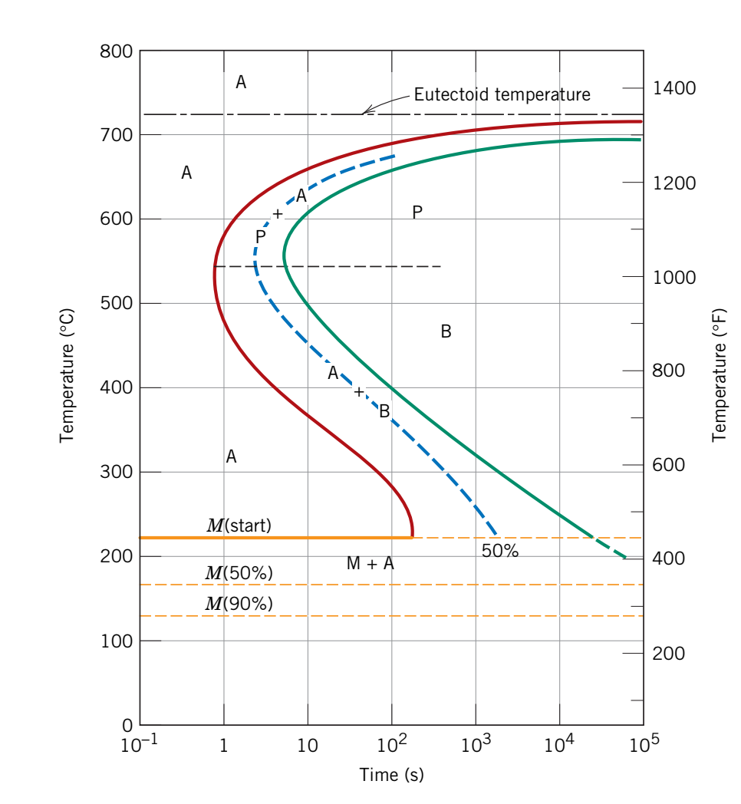 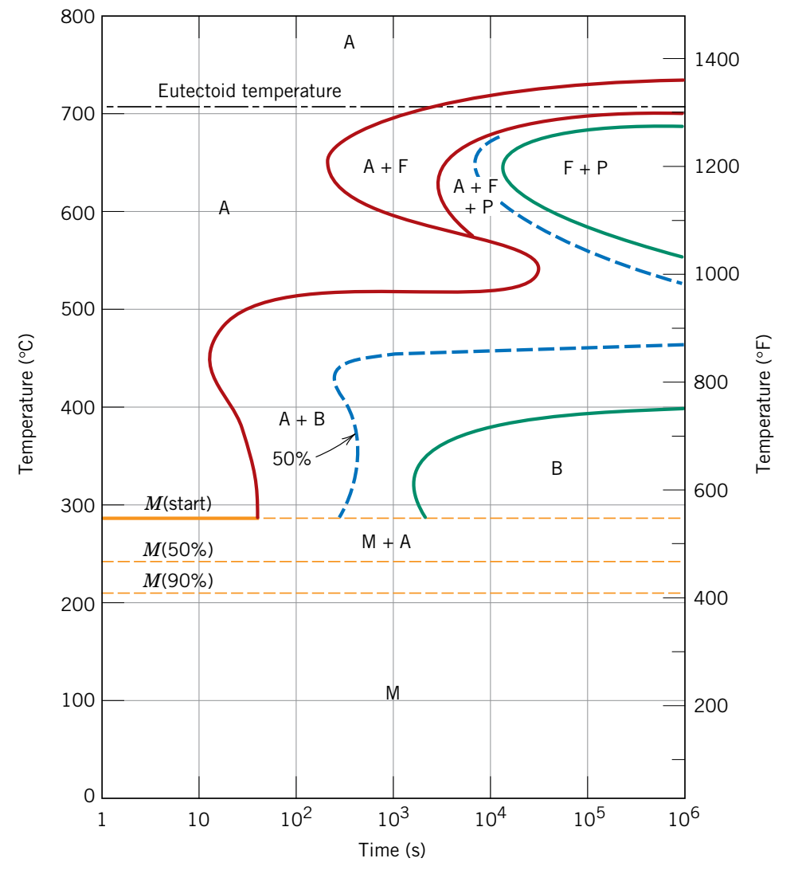

**B**

**A**

*Figure 3: Time-temperature transformation (TTT) diagrams for a typical hypoeutectoid steel of a) plain-carbon and b) alloyed composition [1]*

For steels and steel alloys, TTT diagrams indicate a number of phases which can form beyond those given from an equilibrium phase diagram. Of these phases, three are of note to this experiment:

* Bainite is an analog of pearlite that forms at lower temperatures, or below the pearlite “nose” as seen in Figure 3. This mixture of ferrite and cementite is different in that the cementite forms a more needle-like, elongated shape in the ferrite matrix. Bainite is generally harder than pearlite and has good ductility. This phase can also not be directly transformed into pearlite via a higher temperature.
* High carbon diffusion rates at temperatures just below the eutectoid temperature result in the cementite forming spheres in the ferrite matrix to reduce the surface energy between the two phases; this configuration is known as spheroidite. Given that dislocations can easily move through the ferrite matrix, this microstructure is very soft and weak.
* If a steel is quenched, diffusion is not able to occur, and the carbon that slips out of solid solution will form interstitial impurities in the crystal structure of the iron. This distorts the crystal lattice from face-centered cubic to body-centered tetragonal and forms martensite, a supersaturated solid solution which resembles plates or needle-like shapes.

Martensite is very strong, but often too brittle for engineering applications. Thus, martensite will often be tempered at elevated temperatures well below the eutectoid temperature. Given that martensite is a non-equilibrium phase, carbon will quickly diffuse into small spheres in the material. This allows the steel to maintain its high hardness while increasing its toughness and ductility. Figure 4 illustrates typical microstructures for the three non-equilibrium phases discussed above.

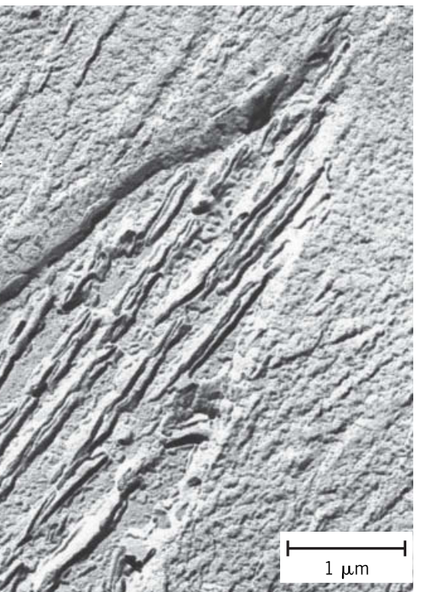 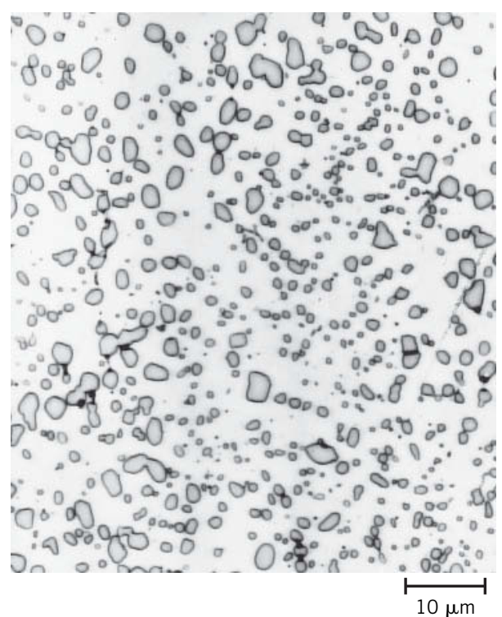 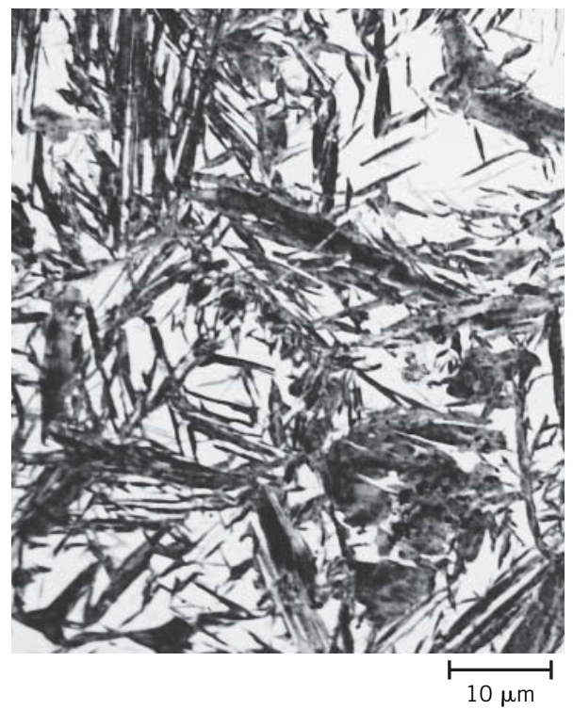

**C**

**B**

**A**

*Figure 4: Typical non-equilibrium microstructures of hypoeutectoid carbon steels: a) bainite, b) spheroidite, and c) martensite [1]*

Continuous-cooling transformation (CCT) diagrams are also used to predict the microstructure of a material. These diagrams tend to be more realistic than TTT diagrams, as they shift the required time of a reaction forward as a function of the cooling rate. For steels, CCT diagrams are significant in that they often show that for low-carbon (<0.25wt%C) steels, martensite may not form due to its required cooling rate being impractically high. Figure 5 shows typical CCT diagrams for hypoeutectoid steels.

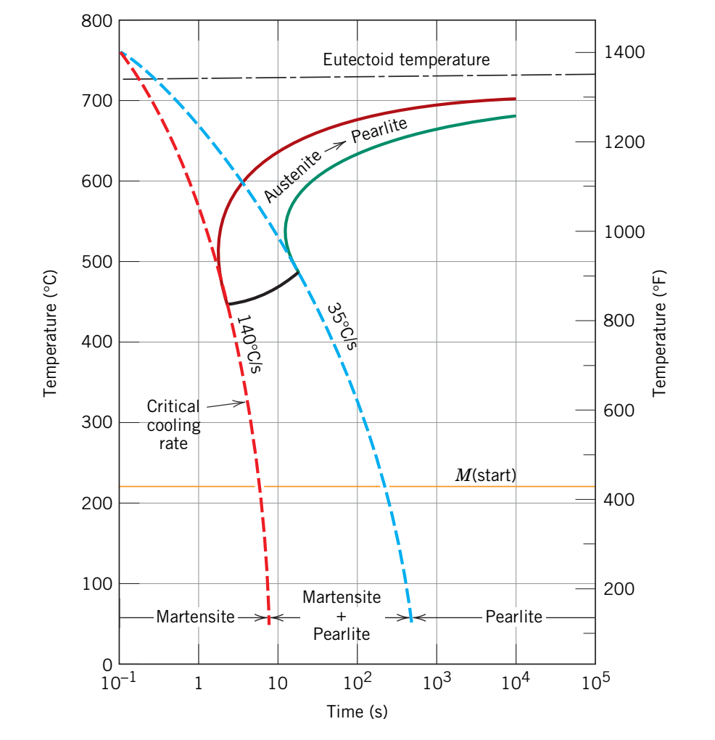 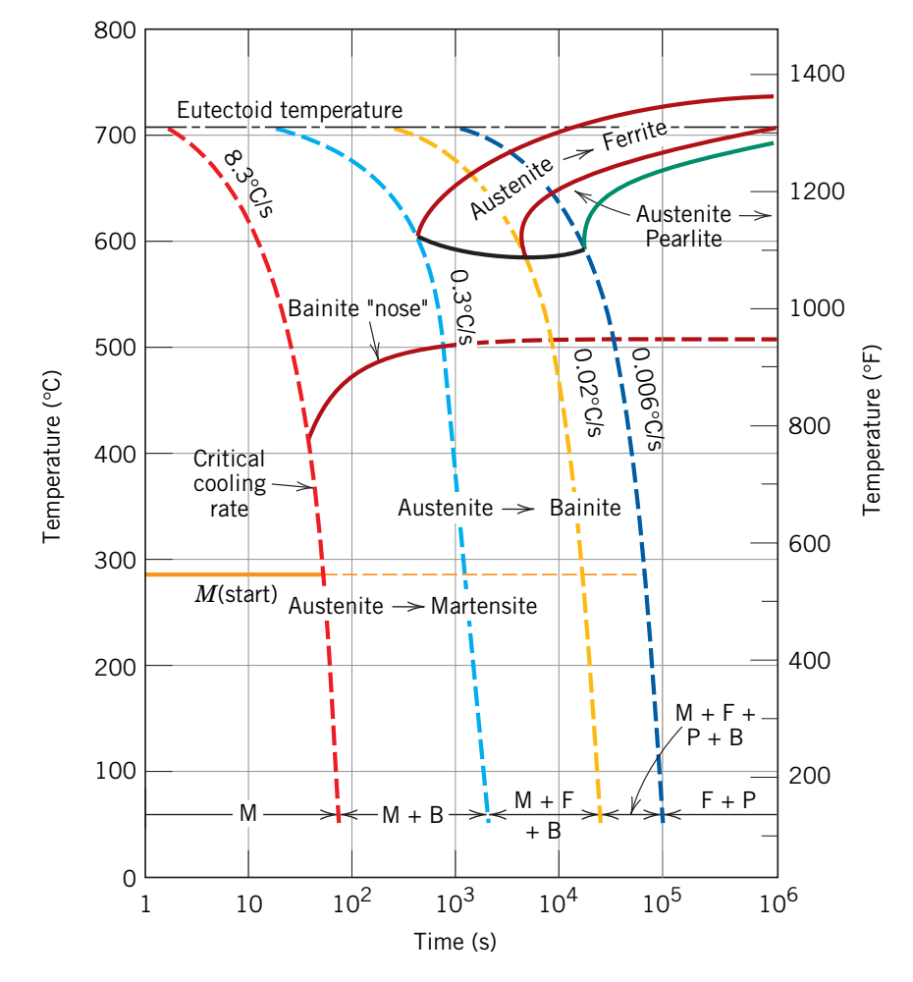

**B**

**A**

*Figure 5: Continuous cooling transformation (CCT) diagrams for a typical hypoeutectoid steel of a) plain-carbon and b) alloyed composition [1]*

For alloyed steels, the addition of elements shifts the TTT curve to the right, which increases the hardenability of the steel, or its ability to form martensite in the steel interior. To measure hardenability, a Jominy end-quench test can be conducted. One end of a steel bar is quenched, and after cooling the hardness is measured horizontally along the bar’s surface. A steel with high hardenability will display higher hardness further away from the quenched end, indicating a more complete martensitic transformation.

**Materials and Methods**

Four steel compositions were selected for testing. The chemical compositions of these samples are listed in Table 1:

|  |  |  |  |  |  |
| --- | --- | --- | --- | --- | --- |
| **Label** | **Designation** | **C (wt%)** | **Cr (wt%)** | **Mo (wt%)** | **Ni (wt%)** |
| A | 1018 | 0.18 | 0 | 0 | 0 |
| B | 1045 | 0.45 | 0 | 0 | 0 |
| C | 4140 | 0.40 | 0.80-1.10 | 0.15-0.25 | 0 |
| D | 4340 | 0.40 | 0.40-0.90 | 0.20-0.30 | 1.65-2.00 |

*Table 1: Chemical compositions of the four steels tested*

Of each composition, 8 cylindrical samples of 1cm in diameter and 1cm in height were received, as was 1 Jominy test bar of approximately 10cm in length.

The 8 small samples were heated to 900°C for 1 hour in a furnace. The following lists the subsequent cooling/annealing schedule for each sample:

1. Water quenched.
2. Water quenched. Heated to 200°C for 1 hour.
3. Water quenched. Heated to 400°C for 1 hour.
4. Water quenched. Heated to 700°C for 1 hour.
5. Water quenched. Heated to 700°C for 24 hours.
6. Air cooled.
7. Quenched in a Pb bath (350°C) for 3 hours.
8. Furnace cooled.

The Jominy test bars were heated to 900°C for 3 hours in a furnace, followed by a quenching on one end of the bar by a continuous stream of water, for approximately 10 minutes. The bars were then air cooled to room temperature. All samples were ground, polished, and etched for optical microscopy according to the following schedule:

1. 240 grit SiC paper
2. 600 grit SiC paper
3. 800 grit SiC paper
4. 1200 grit SiC paper
5. 1μm diamond polish
6. 0.05μm alumina polish
7. Nital (5%) etch

The smaller samples were polished on one cylindrical face. The Jominy bars were polished length-wise on one side to illustrate the change in microstructure as a function of distance from the quenched end of the bars.

All samples were imaged using the Keyence optical microscope. Following microscopy, all samples were hardness tested using a Rockwell C-scale hardness tester. The small samples were tested four times each, and the average was taken to be the hardness of the sample. The Jominy bars were hardness tested at specific length increments from the quenched end to demonstrate the differences in hardenability between each composition.

**Results and Discussion**

The following figures display TTT and CCT diagrams for the four steel compositions tested or those similar:

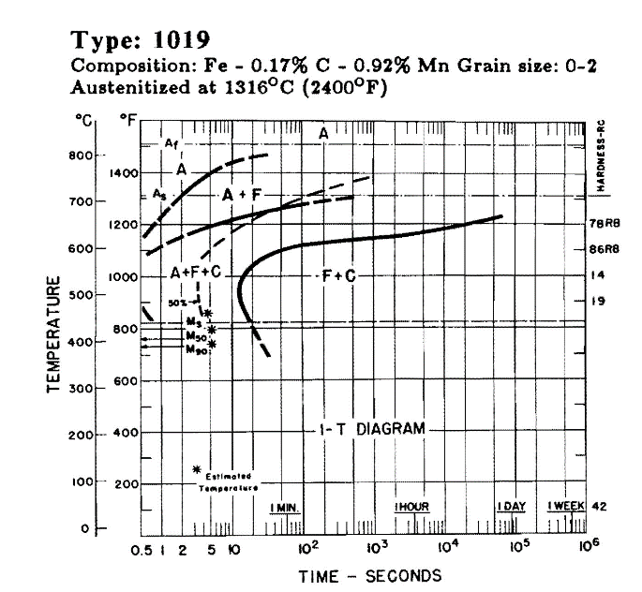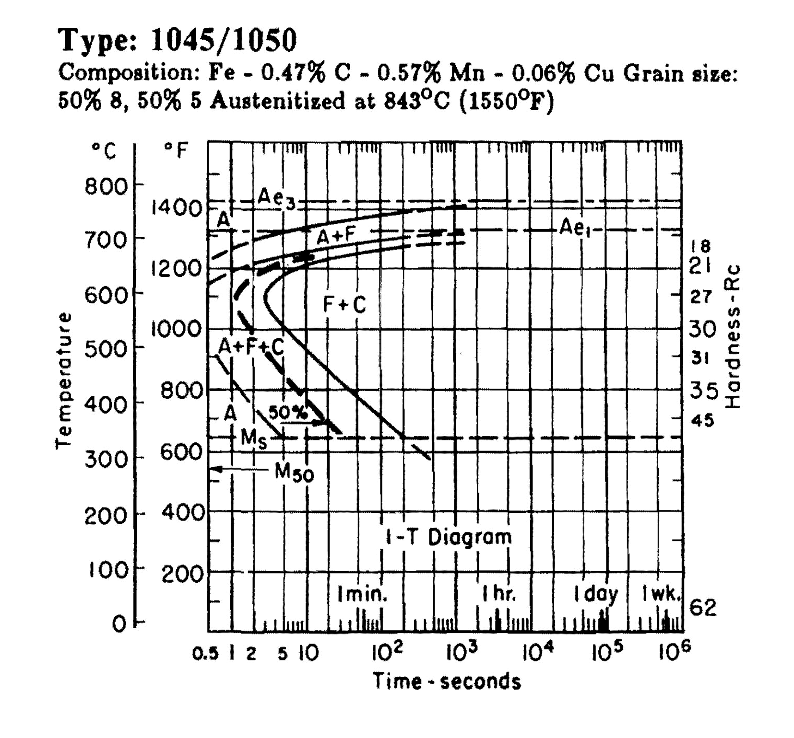

**D**

**C**

**B**

**A**

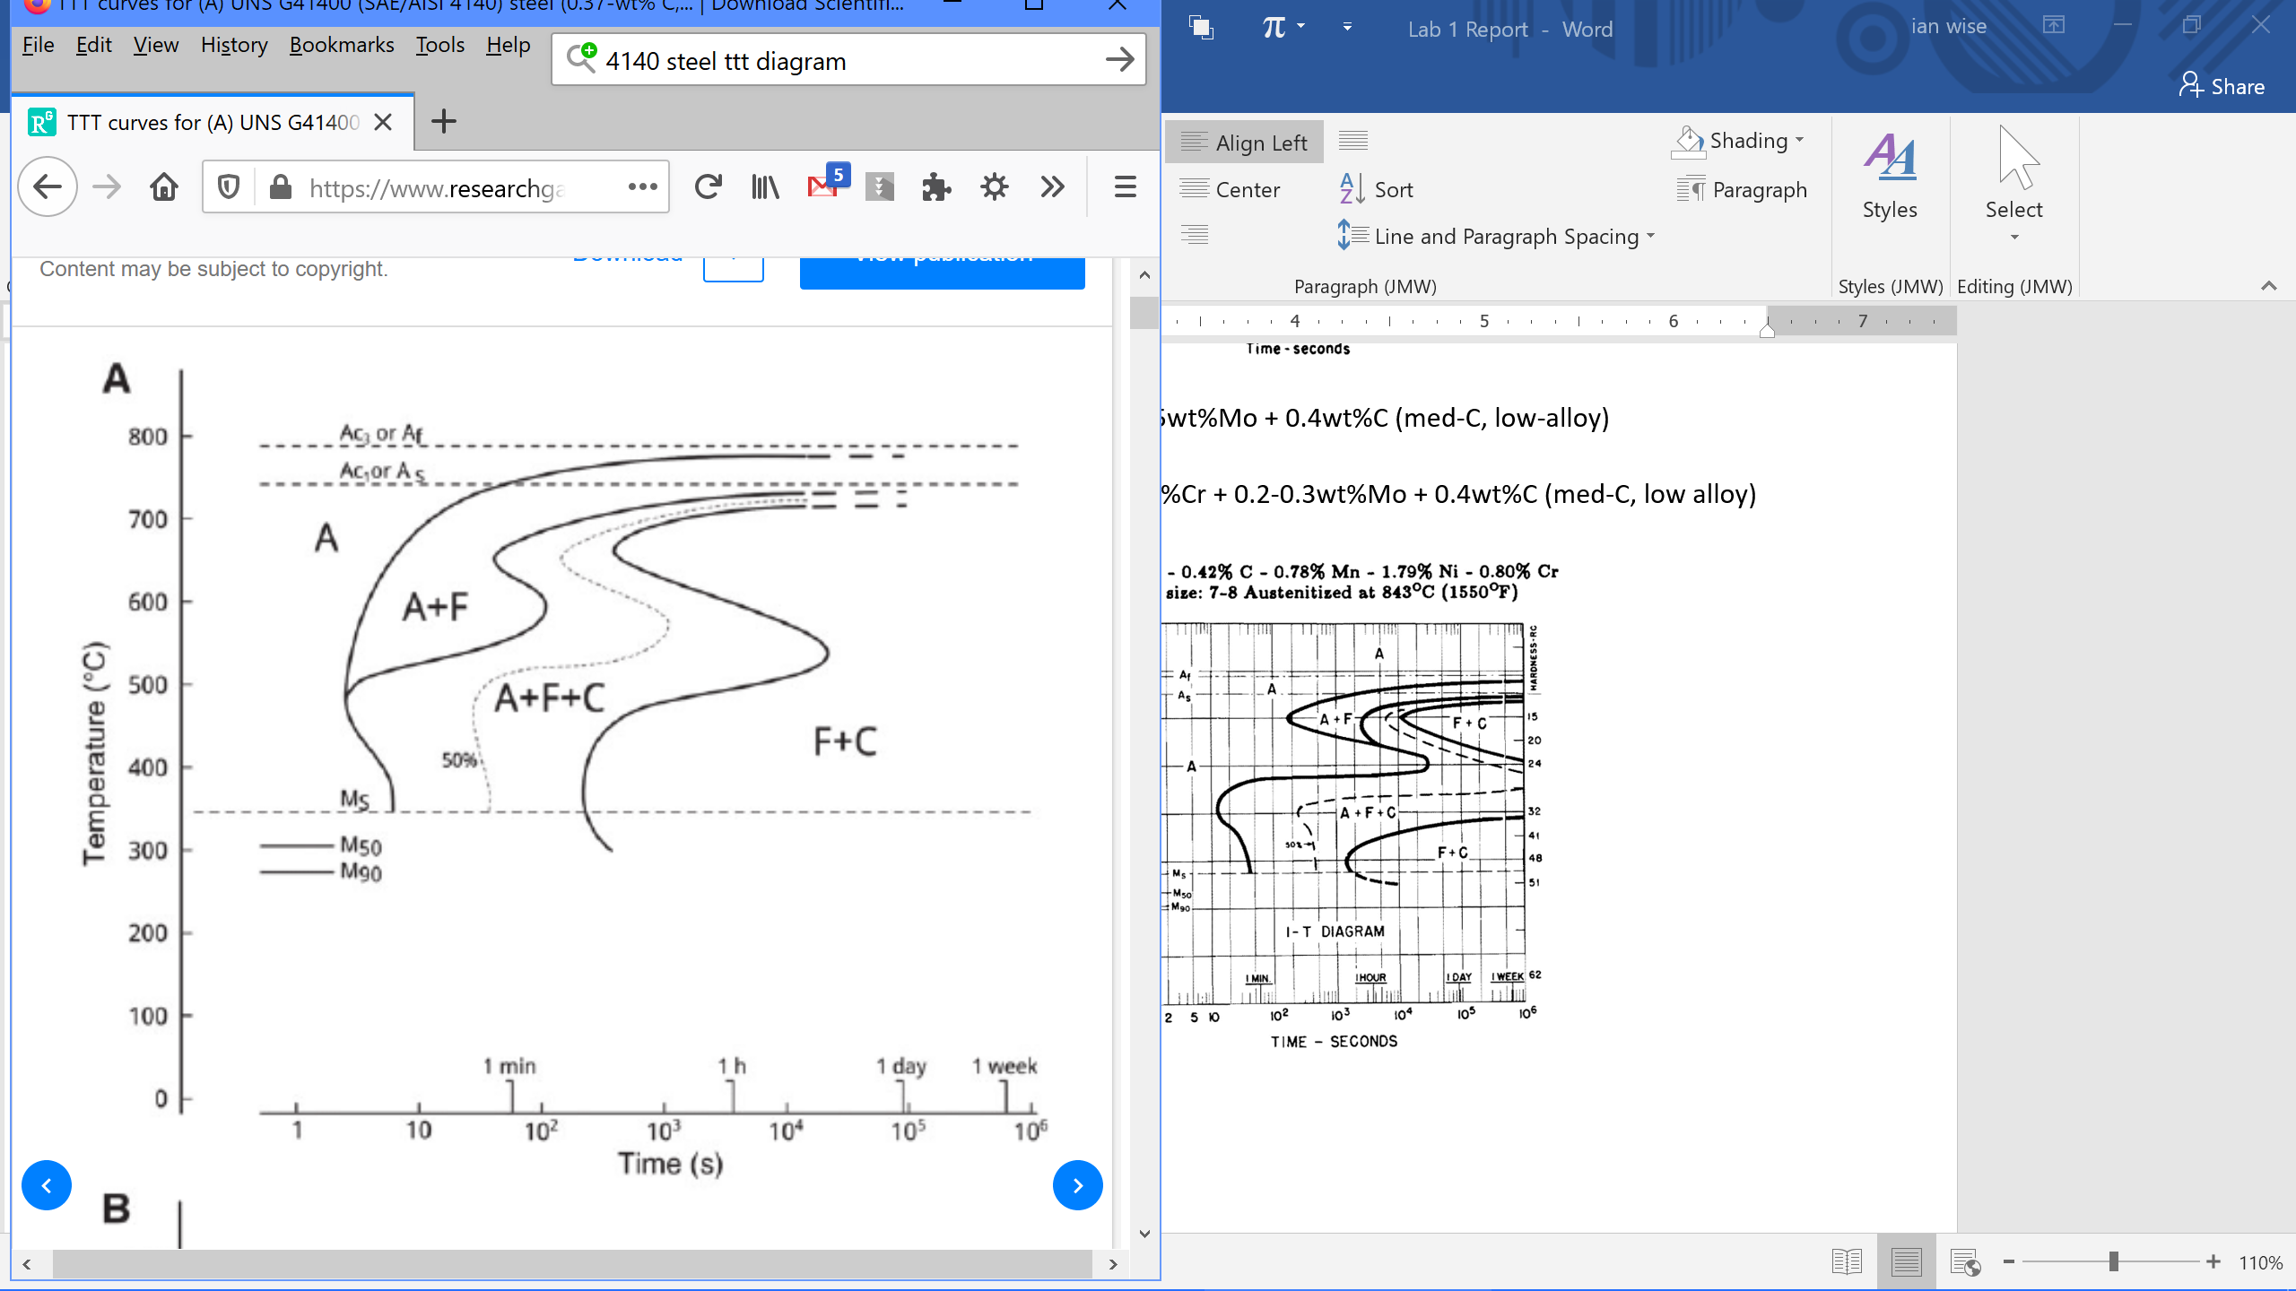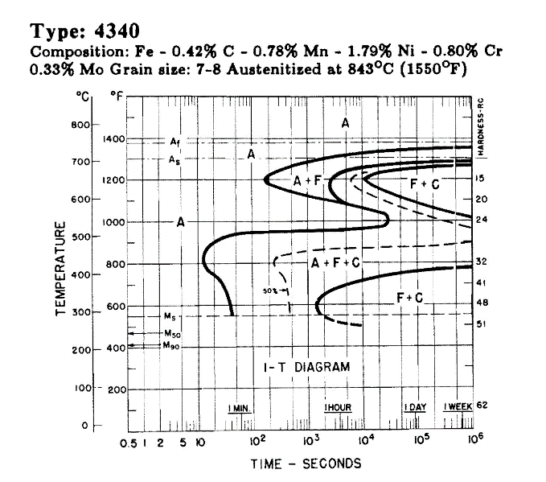

*Figure 6: TTT diagrams for a) 1018, b) 1045, c) 4140, and d) 4340 steel [2]*

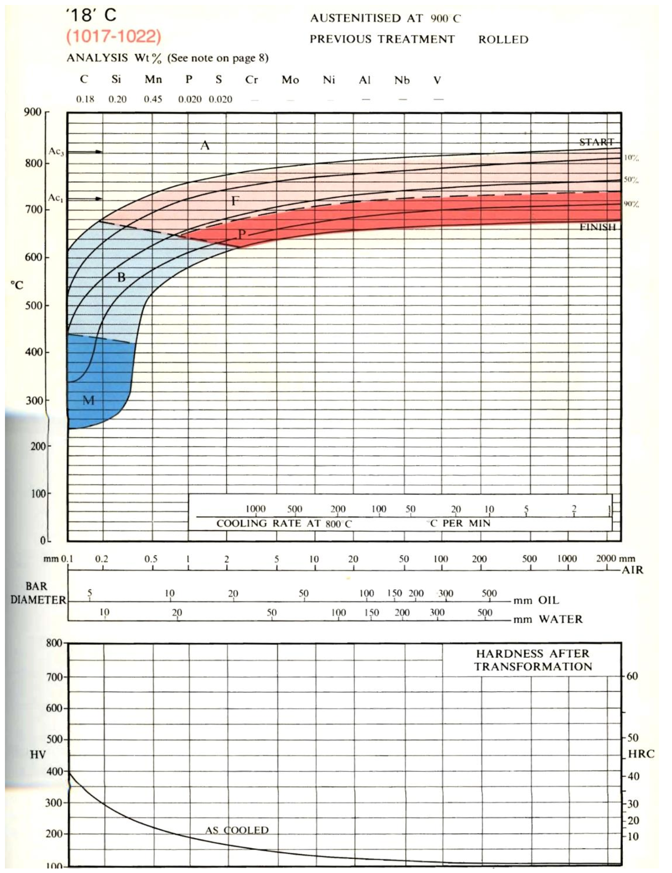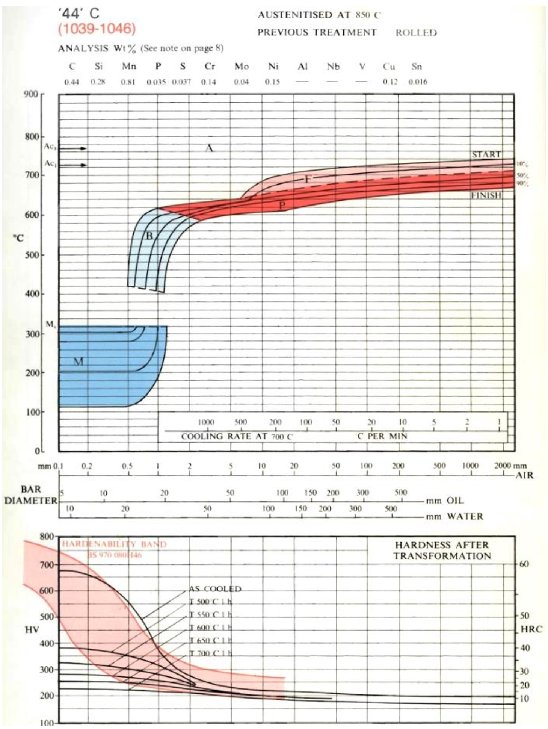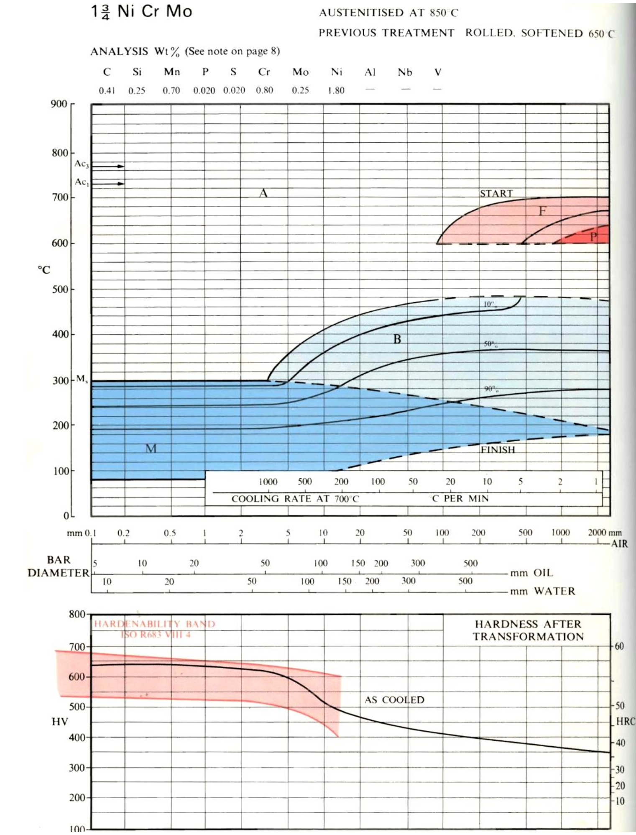

**C**

**A**

**B**

*Figure 7: CCT diagrams for a) low-carbon, b) medium-carbon, and c) Ni-Cr-Mo alloyed steel.*

Figure 7A corresponds closely to the 1018 steel samples (group A). The small blue-shaded area on the left of the graph indicates that a very large cooling rate is required to form martensite without forming bainite first, and this may not be feasible for these samples even with a water quench. At lower cooling rates, such as during an air or furnace cooling, low-carbon steels will ideally form pearlite. Figure 7A also shows that hardness for these samples should rank lowest among all compositions tested, due to the low carbon concentration promoting the growth of soft ferrite.

Figure 7B fits the 1045 steel samples (group B). Again, the figure points to a large cooling rate required to form martensite; however, the scenario is more realistic given that the martensite area extends further to the right. At a lower cooling rate or less intense quench, the 1045 samples should ideally directly form bainite, as opposed to the 1018 samples which, according to Figure 7A, may reach the ferrite area first. A very low cooling rate on Figure 7B will also promote the growth of pearlite. For hardenability, while at small sample sizes (which correspond to higher cooling rates), the hardness of 1045 samples increase exponentially, for the purposes of this experiment the hardness should be relatively equal to that of the 1018 samples.

Figure 7C corresponds most closely to the 4340 steel samples (group D), as it is for a Ni-Cr-Mo alloy; the CCT diagram can be approximated for the 4140 steel samples as well (group C). A larger area corresponding to martensite points to the fact that rapid quenching should induce a martensitic transformation in alloyed steels. Furthermore, the very small pearlite area means that a very slow cooling curve is required to form pearlite; for most slow-cooling scenarios, bainite is likely to form in these samples.

***Optical Microscopy***

All small sample images were taken at 500x magnification. In each table, the letter on each figure corresponds to the sample groups and compositions indicated in Table 1.

*1. Water quenched.*

|  |  |
| --- | --- |
| **A** | C:\Users\Ian\AppData\Local\Temp\17_B1_PostEtch_500x-1.tif  **B** |
| **C** | C:\Users\Ian\AppData\Local\Temp\25_D1_PostEtch_500x.tif  **D** |

*Figure 8: As-quenched a) 1018, b) 1045, c) 4140, and d) 4340 steel samples*

The quenched, unannealed steel samples should ideally have transformed into martensite due to the diffusionless nature of such rapid cooling. Figure 8A shows fewer dark formations than the other samples, which may indicate in incomplete martensitic transformation due to the low-carbon composition. Figure 8B, also plain-carbon steel, does not show a microstructure typical of martensite; instead, the cementite phase appears to have segregated to the grain boundaries of the white ferrite matrix. The darker surface color and needle-like grains in Figures 8C and 8D, both alloy steels, indicate a martensitic transformation.

*2. Water quenched. Heated to 200°C for 1 hour.*

|  |  |
| --- | --- |
| **A** | C:\Users\Ian\AppData\Local\Temp\18_B2_PostEtch_500x.tif  **B** |
| **C** | **D** |

*Figure 9: Quenched a) 1018, b) 1045, c) 4140, and d) 4340 steel samples annealed at low temperature*

After annealing at low temperature, our samples should ideally display tempered martensite – a microstructure similar to spheroidite, but with precipitated cementite spheres much smaller in size. Figure 9A, the 1018 steel, appears darker than in the unannealed sample. Upon higher magnification, one may be able to see the array of precipitated cementite. Conversely, Figure 9C is lighter than in the unannealed 4140 steel sample, which may indicate a more thorough decomposition of the martensite into a stable ferrite/cementite microstructure. However, large dark conglomerations are still present, indicating that not all of the martensite has been transformed. In Figure 9B, it is difficult to assess whether the dark area is high in martensite or the result of uneven etching. In Figure 9D, the surface appears underpolished and displays pitting corrosion. Areas of high carbon concentration cannot be identified.

*3. Water quenched. Heated to 400°C for 1 hour.*

|  |  |
| --- | --- |
| **A** | C:\Users\Ian\AppData\Local\Temp\19_B3_PostEtch_500x.tif  **BV** |
| **C** | C:\Users\Ian\AppData\Local\Temp\27_D3_PostEtch_500x.tif  **D** |

*Figure 10: Quenched a) 1018, b) 1045, c) 4140, and d) 4340 steel samples annealed at medium temperature*

At this higher annealing temperature, the microstructure of these samples should show a more complete transformation from martensite into stable ferrite and cementite. The lighter color of Figure 10A indicates that precipitated cementite has distributed more uniformly through the sample. Figure 10B also shows a lack of martensite across the sample surface. Some small pits can also be seen along the surface. In the 4140 sample corresponding to Figure 10C, the microstructure shows less carbon agglomerations than in the samples annealed at a lower temperature, which may indicate a more uniform dispersion of cementite in the ferrite matrix. The 4340 sample corresponding to Figure 10D appears too unpolished to clearly make out the microstructure; however, one can see some darker patches, which could indicate an area of high carbon concentration or could indicate surface grime.

*4. Water quenched. Heated to 700°C for 1 hour.*

|  |  |
| --- | --- |
| **A** | C:\Users\Ian\AppData\Local\Temp\20_B4_PostEtch_500x.tif  **B** |
| **C** | **D** |

*Figure 11: Quenched a) 1018, b) 1045, c) 4140, and d) 4340 steel samples annealed at high temperature*

Annealing at a temperature close to the eutectoid temperature for 1 hour should ideally yield a microstructure resembling bainite in these samples according to their TTT diagrams. Figure 11B indicates that this transformation has taken place, as one can see the elongated cementite framework running through and around the ferrite matrix. In Figures 11A and 11D, however, the microstructure cannot be determined due to underpolishing/underetching and severe overetching/pitting corrosion, respectively. In Figure 11C, pitting corrosion is also present, but slight dark areas indicate a possible bainitic microstructure, which may be able to be confirmed via higher magnification or more thorough polishing.

*5. Water quenched. Heated to 700°C for 24 hours.*

|  |  |
| --- | --- |
| **A** | **B** |
| **C** | C:\Users\Ian\AppData\Local\Temp\29_D5_PostEtch_500x.tif  **D** |

*Figure 12: Quenched a) 1018, b) 1045, c) 4140, and d) 4340 steel samples annealed at high temperature for a long time*

A long annealing time at just below the eutectoid temperature should yield spheroidite, which can be identified by black dots of cementite large enough to be individually identified at this magnification. In Figures 12B and 12D, one can make out a sea of these dots within the white grains of ferrite, and so these samples show that the transformation into spheroidite was successful. In the 1045 sample, smaller grains of pearlite have also formed, as indicated by the lamellar structure. Small black patches can also be seen in Figure 12A; these may indicate formations of spheroidite or formations of pearlite. The microstructure is less clear in Figure 12C, although the surface is more uniform than in the sample heated for 1 hour at the same temperature.

*6. Air cooled.*

|  |  |
| --- | --- |
| **A** | **B** |
| **C** | C:\Users\Ian\AppData\Local\Temp\30_D6_PostEtch_500x_USE.tif  **D** |

*Figure 13: As-air cooled a) 1018, b) 1045, c) 4140, and d) 4340 steel samples*

Layers of pearlite should ideally form in these samples due to the relatively low cooling rate in air. In Figure 13B, the microstructure appears quite textured, indicating that pearlite may have formed. However, it is difficult to tell if the darker patterning resembles the lamellar structure typical of pearlite. Similarly, the microstructure is difficult to discern in the other samples. In Figure 13A, beyond the corrosion of the surface one can make out many dark blotches, which at lower magnifications can be indicative of pearlite formation. Figure 13C appears to be overetched, which obscures the microstructure. In Figure 13D, the darker formations may be due to overetching or may be pearlite formations, but it is difficult to discern between the two scenarios.

*7. Quenched in a Pb bath (350°C) for 3 hours.*

|  |  |
| --- | --- |
| **A** | C:\Users\Ian\AppData\Local\Temp\23_B7_PostEtch_500x.tif  **B** |
| **C** | C:\Users\Ian\AppData\Local\Temp\31_D7_PostEtch_500x.tif  **D** |

*Figure 14: As-lead quenched a) 1018, b) 1045, c) 4140, and d) 4340 steel samples*

A fast quench from 900°C should form some martensite in these samples, and the long time held at this temperature may form a bainite microstructure as well. Figure 14D appears too underpolished to discern a bainite microstructure, and the needle-like formations indicative of martensite area also not present. In Figure 14C, the similarity of the color and texture of the surface to samples annealed at high temperatures may indicate that martensite did not form. Bainite or martensite appears to be present in Figure 14A, as shown by the sea of darker formations. Unfortunately, the microstructure in Figure 14B cannot be determined, as either the sample is heavily etched or the contrast obscures the grain boundaries.

*8. Furnace cooled.*

|  |  |
| --- | --- |
| **A** | **B** |
| **C** | C:\Users\Ian\AppData\Local\Temp\32_D8_PostEtch_500x.tif  **D** |

*Figure 15: As-furnace cooled a) 1018, b) 1045, c) 4140, and d) 4340 steel samples*

Having the slowest cooling rate, pearlite should be the dominant phase transformation in these samples. Figure 15A has a very dark surface, and this may be due to overetching which obscures the true microstructure. Pearlite formations can be seen in Figures 15B and 15D, as indicated by formations of dark patches speckled with light spots; these speckles at a low magnification can indicate a lamellar structure. In Figure 15C, two distinct areas have been shown, one light and one dark. This may be due to an uneven polish or etch, but one can clearly make out dark patches throughout the surface which may indicate pearlite formation.

Jominy bars were imaged near the middle of each bar, to illustrate the difference in the extent of martensite formation from the quenched end for each composition. Images for samples A and C were taken at 500x magnification, and for samples B and D 1000x magnification.

|  |  |
| --- | --- |
| **A** | **B** |
| **C** | **D** |

*Figure 16: Jominy bars of a) 1018, b) 1045, c) 4140, and d) 4340 steel samples*

Ideally, the plain-carbon steels should appear lighter due to a lower martensite concentration. Figure 16D, an alloy steel, illustrates martensitic transformation upon quenching. The needle-like, dark concentrations are martensite. Conversely, Figure 16C is much lighter and has an orange hue, which may indicate a majority ferrite concentration. The lack of martensite may be due to an insufficient quenching time. An uneven surface in Figure 16B makes it difficult to assess the microstructure. The dark blotches on the surface are not typical of martensite, but do indicate cementite agglomeration, which is more typical of a medium-carbon steel. In Figure 16A, the lines of dark areas may be due to polishing or surface imperfections.

***Hardness***

Figure 17 lists hardness data for each small sample. Ideally, one should see the lowest average hardness in the rightmost grouping, as a long annealing time should form spheroidite, a soft phase of steel. Likewise, the as-quenched samples should form martensite upon quenching, and thus should exhibit the highest hardness. Furthermore, the 1018 carbon steel should ideally be softer than the other samples due to the lower carbon content promoting the growth of soft ferrite.

The hardness data appears to agree with ideality. The annealed samples generally trend downward in hardness as the temperature and time of annealing increases. This trend makes sense due to more decomposition of the harder martensite phase with higher temperature annealing and longer annealing times. Samples which experienced lower initial cooling rates, namely the air-cooled furnace-cooled samples, generally display higher hardness than the high-temperature annealed samples, but a lower hardness than the low or mid-temperature annealed samples. From this data and using the CCT diagrams of these steels, one could draw a conclusion as to at how high a temperature quenched steels must be tempered to overcome their initial martensite formation, to a point where ductility is improved (hardness is lowered) versus via convection cooling.

In most sample groups, the medium-carbon steels exhibit a much higher hardness than the 1018 (A) group. This trend is expected, as a higher carbon concentration equates to a more thorough growth of cementite in the steel, which with its brittleness will contribute to a high hardness. Some samples were also initially measured using a Rockwell B scale and later converted to Rockwell C. However, samples A and B for the furnace-cooled group were not able to be converted.

***Hardenability***

Figure 18 illustrates the results of the Jominy bar hardenability test. Unfortunately, hardness measurements for each bar were taken starting from the cap of the bars towards the quenched end. Thus, the trend in hardness for ach sample is slightly increasing as with each measurement a more martensite-rich area is reached. Samples C and D, the alloy steels, have a higher hardness than Sample B, the 1045 plain-carbon steel. This trend fits well with the CCT diagrams for alloy steel and medium-carbon steel in Figure 7. The addition of alloying elements into the iron induces precipitation hardening and strengthening mechanisms, which contribute to the hardness of the steel. As can be seen in the TTT diagrams in Figure 6, the hardenability of alloyed steels should increase as well. The shifting of the bainite/pearlite nose to the right indicates that more martensite will form in these samples, and so the hardness should remain high for a longer portion of the sample. However, since the slopes of the data lines in Samples B, C, and D are all similar, increased hardenability in the alloyed steels was not observed. Sample A was tested under the Rockwell B scale and could not be converted to Rockwell C to be compared to the other samples; however, given the average hardness measured, if hardness measurements were initially taken under a C scale, Sample A should roughly align with Sample B. Jominy bar hardness measurements were not able to be remeasured due to the existing hardness measurements artificially hardening the sample surface by forming compressive stress concentrations.

**Summary**

Overall, the experiments conducted to observe the effects of carbon content and annealing temperature and time on steel fit well with theory. Samples with lower carbon concentrations displayed less martensite formation in the surface microstructure and a lower hardness. Furthermore, samples annealed at higher temperatures and for a longer period of time exhibited lower hardness and a higher percentage of ferrite. The Jominy hardenability test somewhat fit theoretical predictions. Higher hardness among the alloyed steel samples as compared to plain-carbon steels was expected. However, a higher hardenability among the alloyed steels was not observed. Improper hardness calculations also prevented accurate comparison of hardenability among some samples.

Quench-hardened steels often exhibit very high hardness and strength due to martensite formation, but at the cost of ductility required for many structural applications. However, there are still uses and research conducted for quench-hardened steels. In the automotive and machinery industry, quench-hardened carburized steels are often integrated into small parts such as gears and drills, which must withstand very high stresses and temperatures [3]. The automotive industry has also begun to utilize these steels in the body of vehicles (e.g. door beams, bumpers, cross bars) to capitalize on low weight and structural performance [4]. Quench-hardened steels are commonplace in the oil & gas and tool-making industries; quenched alloy steels such as MnCrB, NiCrSi, and NiCrMoV have been studied to determine their mechanical properties for use in these applications [5]. Martensitic steels have been widely used in drill piping, casing, and tubing in oil drilling, and have been researched to improve their resistance to stress corrosion from sulfide contamination, which reduces their effectiveness [6]. Finally, both ferrite and martensite exhibit a relatively high magnetic permeability; thus, martensitic stainless steels (containing Cr) can also find applications for use in solenoid cores and permanent magnets [7]. As more research into the properties of martensite and martensitic steels is done, it is likely that the opportunities for their use in industry and manufacturing will expand.

**References**

[1]. Callister, W. D.; Rethwisch, D. G. *Fundamentals of Materials Science and Engineering: An Integrated Approach*, 5th ed. John Wiley & Sons, Inc., **2015**.

[2]. Kappes, M.; Iannuzzi, M.; Bebak, R. B.; Carranza, R. M. Sulfide stress cracking of nickel containing low-alloy steels. *Corrosion Reviews*, 2014, 32, pp. 101-128.

[3]. Su, S.-r.; Song, R.-b.; Chen, C.; Wang, J.-y.; Zhang, Y.-c. The novel process of spheroidizing-critical annealing used to optimize the properties of carburized steel and its effect on hardening mechanism of quenching and tempering. *Materials Science and Engineering: A*, **2019**, 765, 138322.

[4]. Horvath, C.D. “Advanced steels for lightweight automotive structures.” *Materials, Design and Manufacturing for Lightweight Vehicles*, Woodhead Publishing, **2010**, pp. 35-78.

[5]. Abbasi, E.; Luo, Q.; Owens, D. A comparison of microstructure and mechanical properties of low-alloy-medium-carbon steels after quench-hardening. *Materials Science and Engineering: A*, **2018**, 725, pp. 65-75.

[6]. Wang, Q.; Sun, Y.; Gu, S.; He, Z.; Wang, Q.; Zhang, F. Effect of quenching temperature on sulfide stress cracking behavior of martensitic steel. *Materials Science and Engineering: A*, **2018**, 724, pp. 131-141.

[7]. “Magnetic Properties of Ferritic, Martensitic and Duplex Stainless Steels.” *British Stainless Steel Association*, British Stainless Steel Association, 2018, www.bssa.org.uk/topics.php?article=3.

**Appendix**

*A. Small sample hardness measurements*

|  |  |  |  |  |  |
| --- | --- | --- | --- | --- | --- |
| Composition | Sample # | Hardness1 | Hardness2 | Hardness3 | Hardness4 |
| A (1018) | 1 | 21.5 | 23.5 | 19.5 | 20 |
| A (1018) | 2 | 11.5 | 14 | 18 | 14 |
| A (1018) | 3 | 28.0 | 26 | 32 | 31 |
| A (1018) | 4 | 87.0 | 95 | 94 | 94 |
| A (1018) | 5 | 86.0 | 91 | 85 | 91 |
| A (1018) | 6 | 86 | 88 | 88.0 | 91.0 |
| A (1018) | 7 | 89.0 | 93 | 93.5 | 92.5 |
| A (1018) | 8 | 76.0 | 77.5 | 78 | 82 |
| C (4140) | 9 | 53.0 | 56 | 57 | 59 |
| C (4140) | 10 | 44.0 | 47 | 47.5 |  |
| C (4140) | 11 | 43.0 | 44 | 43 | 42 |
| C (4140) | 12 | 21.0 | 23 | 19 | 20 |
| C (4140) | 13 | 9.0 | 5 | 2 | 8 |
| C (4140) | 14 | 26.0 | 22 | 24 | 26 |
| C (4140) | 15 | 25.0 | 27 | 29 | 26 |
| C (4140) | 16 | 89.0 | 91 | 91 | 93 |
| B (1045) | 17 | 57.5 | 57 | 54 | 59 |
| B (1045) | 18 | 47.0 | 49 | 46 | 49 |
| B (1045) | 19 | 40.0 | 38.5 | 40.5 | 43 |
| B (1045) | 20 | 12.5 | 12 | 11 | 13 |
| B (1045) | 21 | 3.5 | 4 | 3.5 | 4.0 |
| B (1045) | 22 | 37.5 | 39 | 41 | 37.5 |
| B (1045) | 23 | 43.0 | 51.5 | 50 | 56.5 |
| B (1045) | 24 | 0 | 0 | 0.0 | 0.0 |
| D (4340) | 25 | 41.0 | 42 | 45 | 46 |
| D (4340) | 26 | 43.0 | 45 | 47.5 | 44.5 |
| D (4340) | 27 | 41.0 | 42.5 | 40 | 40.5 |
| D (4340) | 28 | 19.0 | 21 | 22 | 18 |
| D (4340) | 29 | 8.5 | 9.5 | 7.5 | 9.5 |
| D (4340) | 30 | 13.5 | 16.5 | 12 | 12 |
| D (4340) | 31 | 29.0 | 29.5 | 31 | 25 |
| D (4340) | 32 | 11.0 | 13 | 14 | 15.5 |

*B. Jominy hardenability test results*

|  |  |  |  |  |
| --- | --- | --- | --- | --- |
| **Distance from end of bar (inches)** | **A (1018)** | **B (1045)** | **C (4140)** | **D (4340)** |
| 0.125 | 85 | 2 | 11 | 23 |
| 0.25 | 83 | 6 | 13 | 25 |
| 0.375 | 79 | 10 | 15 | 28 |
| 0.5 | 80 | 8 | 15.5 | 25 |
| 0.625 | 94 | 7.5 | 19 | 26 |
| 0.75 | 73 | 9 | 19 | 25 |
| 0.875 | 97 | 9 | 20 | 25 |
| 1 | 99 | 10 | 26 | 27 |
| 1.125 | 72 | 10 | 21 | 23 |
| 1.25 | 94 | 10 | 24 | 25 |
| 1.5 | 90 | 9 | 19 | 27 |
| 1.75 | 92 | 11 | 11 | 25 |
| 2 | 95 | 11 | 20 | 27 |
| 2.25 | 95 | 14.5 | 21 | 30.5 |
| 2.5 | 98 | 14 | 14 | 30 |
| 2.75 | 93 | 15 | 23 | 33 |
| 3 | 95 | 16 | 25 | 32 |
| 3.25 | 91 |  | 22 |  |